Pillars’ Trip to Krakow, Poland Wednesday 3rd – Saturday 6th July

The implementation of Millgate’s new morality-based curriculum ‘Pillars’ this year has given students a platform to deliberate the ethical and moral impact of historical world events. These discussions have been tied in with individual and personal reflections on students’ opinions of the world to build on their identities as Millgate Men.
Such a successful year of onsite and offsite experiences for our students was celebrated in the Pillars’ trip to Krakow, Poland last week. On this trip students faced a breadth of challenges; from boarding a plane for the first time, to visiting the emotional sites of Auschwitz and Birkenau.
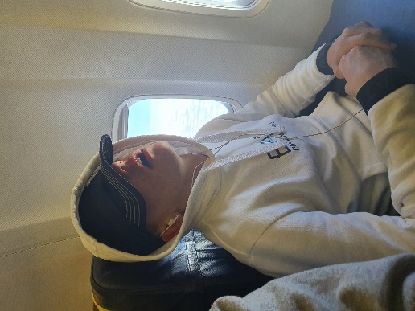
Day 1 – Students were up and off site by 6:30am as we made our way to East Midlands’ airport. Two of our nine students had never been on a plane, with three other’s only having experienced it once before. The boys were brilliant when it came to the always rather stressful part of travelling; going through security. All students managed their behaviour impeccably and listened well to security staff. On the flight, students supported each other with a rather turbulent landing and, before leaving the plane, Syrus (who plans to become a pilot himself) was able to see the cockpit and talk to the pilot. The rest of the day was spent settling in to our hotel and walking around the local area.
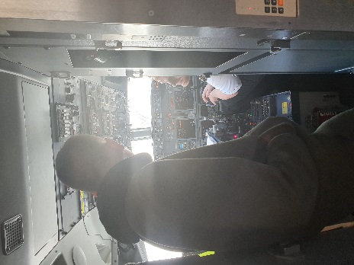
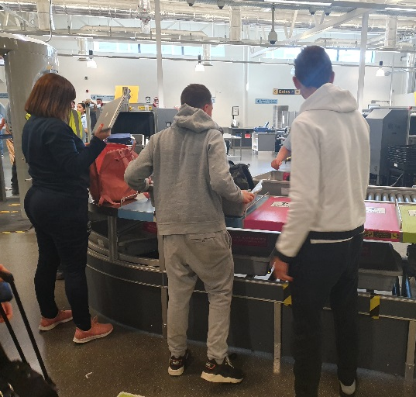
Day 2 – An early rise for the boys as we made our way by coach to the concentration camps Auschwitz and Birkenau. Students had been prepared for this visit with several Pillars lessons on the Holocaust and the concentration camps themselves. Staff were aware that visiting such an emotional and well-respected site could potentially see some boys struggle; we need not have worried at all. As we followed our guide around both sites, students were incredibly respectful of the horrific atrocities that were on display. The boys asked questions of our tour guide and were genuinely interested to discuss how and why such events had been able to take place. I know I can speak for all staff involved when I say that we could not have been prouder of the boys that day. Our tour guide stated as we left that she was used to having groups of young students, but she was not used to the level of respect shown by our boys and thanked us for having visited.

Day 3 – After having seen the atrocities of Auschwitz-Birkenau the previous day, on the third day we made our way to Schindler’s Factory Museum to learn more of Oskar Schindler (a Nazi German who had save over 1,200 Jews during the Holocaust) and the impact that the German invasion during WW2 had on the city of Krakow. The boys enjoyed how interactive this museum was and were shocked to learn of how the Nazi party had been able to have so much control. The boys battled with the idea that the people of Krakow would not just rebel against this invasion. As our guide pointed out the terror tactics of the Nazis, the boys began to understand the level of fear that was felt by all living in Krakow at this time. The museum tour ended in the ‘Room of Reflection’. Here the boys were asked whether they would have ignored the injustice going on around them or if they would have risked their lives to save those in need. All students recognised that they would have had to help through them all having a very strong sense of right and wrong as well as a belief of fairness. A man following our group spoke to Sara after our tour and said how impressed he had been with the questions the boys had asked and their behaviour.
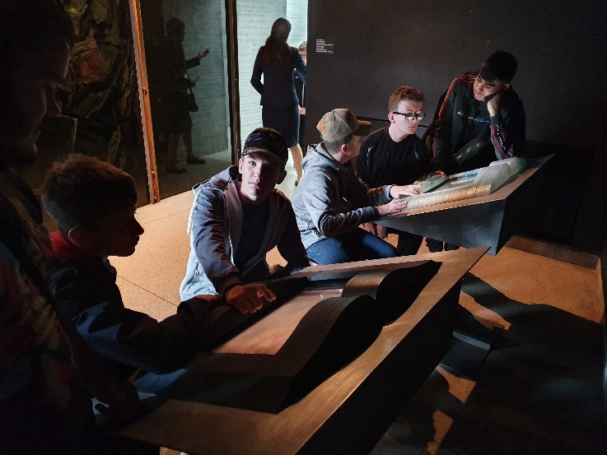

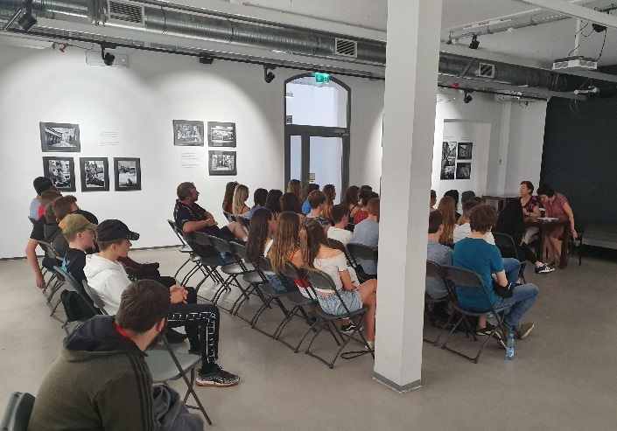
Day 4 – The first activity in our final day in Poland was hearing the story of a Holocaust survivor. We visited the Galicia Jewish Museum where we heard the story of a Jewish woman who was born in the Krakow Ghetto, who’s dad had worked for Oskar Schindler and how she had had to have her identity changed completely to survive the war. The boys amazed us further as they sat and listened for an hour to this story being translated in to English in a room with another school. At the end of the talk, the survivor asked the students if they felt that the Holocaust should still be remembered or if it needed to be forgotten in history. Rayhan answered, “it should be remembered so that history doesn’t repeat itself.”
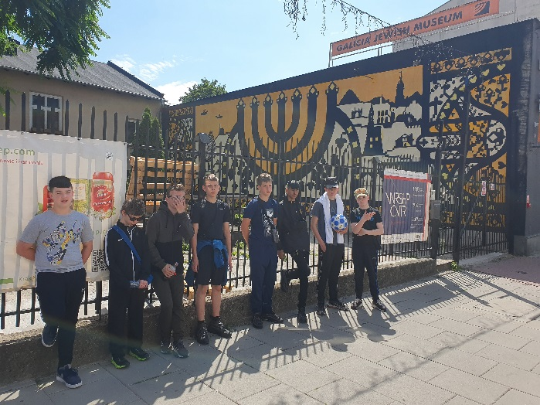
When planning this trip, I knew that it was going to be a very special experience for Millgate students; I did not realise just how resilient and reflective our boys would be. The nine boys we took showed such levels of respect it moved each one of the four members of staff who went. Such an experience for boys of Millgate’s demographic is not one that happens very often within our sector; through fear of how they will manage. I could not be happier or more proud of how the students rose to the challenge; to show the levels of empathy, maturity and resilience that boys with SEMH can have when given a platform on which to prove it.

