The Middle Chapters
The Squashies, 30th August – 8th October, 2021
English – My Beautiful Space
The Artist |  |  | Through their study of poetry and short stories and visits around Leicester and Leicestershire, students will learn how writers use language and linguistic devices for effect and create character and setting. They will then use the skills of an artist to write their own descriptions and then edit and perfect them to create a thing of beauty.
 |  |  | Learning Intentions |  | Big Learning Questions |  | Assessment Products |  | Links to Curriculum Standards
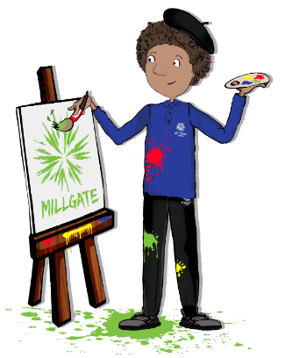  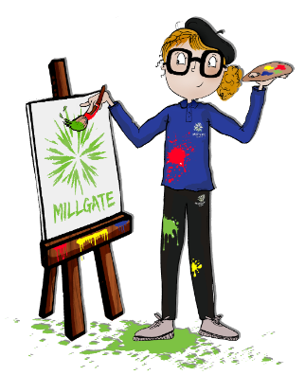 |  | WEEK 1 | - To learn how to identify and apply linguistic devices in your own writing. |  | How do writers create images with words?  How do writers use linguistic devices to engage readers?  How could you increase your vocabulary? |  | Write a class travel advert for Bradgate Park. |  | Year 6 ARE:  Reading:  - I can evaluate how authors have structured their texts.  Writing:  - I can write for a range of purposes and audiences.  - I can select appropriate vocabulary and grammar for a piece of writing to reflect task, purpose and audience.  - I can punctuate accurately.  GCSE assessment criteria:  Level 2: AQA GCSE English Language  - AO2 – Make some comments on language and structure.  - AO5 – Content: Begins to vary vocabulary with some use of linguistic devices.  - AO5 – Organisation: Attempts to use structural features.  - AO6 – Punctuation: Attempts to use parenthetic sentences.
 |  | WEEK 2 | - To learn how writers create a sense of place and establish a setting. |  | How do writes create atmosphere?  How do writers use different techniques to create good descriptions?  How do writes use their senses to create their descriptions? |  | Write your own opening to a descriptive piece that establishes a clear setting.
 |  | WEEK 3 | - To learn how to use verbs, adverbs and adjectives for effect in sentences. |  | Why are verbs, adjectives and adverbs useful in descriptive writing?  Where are these words best placed within your sentence construction? |  | Create your own class video of your favourite adverbs, verbs and adjectives.
 |  | WEEK 4 | - To learn how writers describe characters.  - To learn how to write a description of a character. |  | How can you use your linguistic techniques to enhance your description?  What does it mean to show and not tell?  What are your idiosyncrasies? How could you incorporate them into your writing? |  | Write your own description of a character, based on a ‘people watching session’.
 |  | WEEK 5 | - To learn how to structure a description. |  | What does Todorov teach us about good writing?  What does a descriptive piece not include?  How do writers effectively guide us through a space? |  | DRAFTING: Write your description based on your photograph taken at a space in Leicester.
 |  | WEEK 6 | - To learn how to edit and enhance a piece of written work. |  | What techniques can you recall from your baseline assessment?  How can you develop what you have already written?  What skills have you already learnt and mastered? |  | FINAL EDIT: Write your description based on your photograph taken at a space in Leicester.
STUDENT ACADEMIC TARGETS

